2026 Lapsed Member Win Back
Campaign
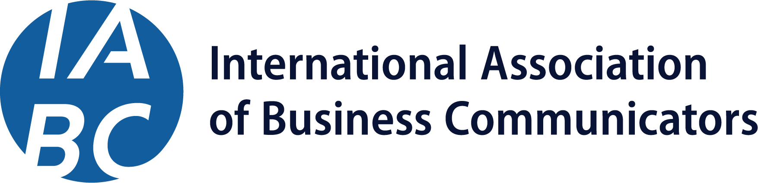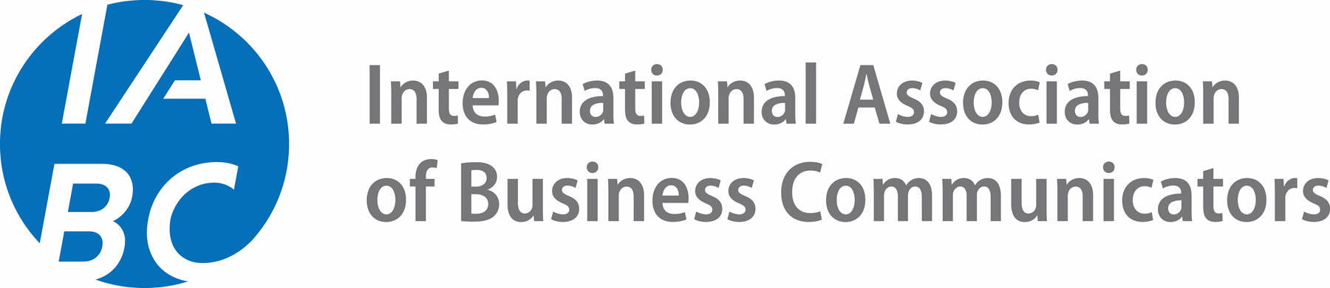
Prepared by: S. Mitchell

Campaign/Project Name | 2026 Lapsed Member Win Back Campaign
Timeline (Start/End) | April – June 2026

Overview
IABC will run a coordinated lapsed member win back campaign starting in late April and running through the end of June 2026, highlighting the benefits of returning to IABC membership and offering prorated membership for the remainder of 2026.

Since this audience is already familiar with IABC, the campaign will focus on short, to-the-point messaging highlighting new member benefits and the opportunity to rejoin at a discount. Since there is a targeted audience for this campaign, email and Propfuel will be our primary communication channels.

We will offer a 30% discount on Professional and Plus memberships to this audience through 30 June 2026 using promo code LOVEIABC.

Targeted Messaging and Taglines
- Sample Messaging
  - You’ve been part of IABC before. Come back and get what you need — now at a lower cost.
  - We miss you! Come back to IABC and enjoy 30% off your 2026 membership.
- Sample subject lines:
  - Come back to IABC and save 30%
  - We’d love to have you back
  - Your IABC membership, 30% off
- Sample CTAs
  - Rejoin IABC
  - Come back
  - Pick up where you left off
  - Get 30% off
  - Join again

Emphasis On Membership Options and New Benefits
Across platforms, HQ will emphasize new membership options and associated costs, with a focus on flexibility and discounted options for Professional and Plus memberships.

This audience is already familiar with IABC member benefits, so HQ will focus on newer additions to those benefits, including SIGs, partnerships, and the IABC Online Community.

Campaign Goals
This campaign seeks to entice lapsed IABC members to recommit to the organization. We seek to convert 375 lapsed members to return.

Deliverables & Scope
This campaign will be comprised of six (6) dedicated emails and a 4-touchpoint Propfuel campaign from HQ throughout the timeline, in addition to dedicated advertising on LinkedIn and Google.

HQ will share campaign performance trends with the IABC International Executive Board, in addition to any findings that can benefit future campaigns.

Communication Timeline
- April 2026
  - 24 April: dedicated email
  - 28 April: Propfuel touchpoint 1
- May 2026
  - 8 May: dedicated email
  - 12 May: Propfuel touchpoint 2
  - 22 May: dedicated email
  - 28 May: Propfuel touchpoint 3
- June 2026
  - 10 June: dedicated email
  - 17 June: Propfuel touchpoint 4
  - 23 June: dedicated email
  - 30 June: dedicated email (last chance)

Target Audience & Messaging
Recently lapsed IABC members
This campaign and discount will focus on all those whose memberships expired at the end of 2024 and 2025.

Voice & Tone
The voice and tone for this campaign will follow IABC’s professional and friendly personality and style guide, while encouraging engagement across platforms.

Sample Copy
Sample 1
You’ve been part of IABC before, so you know what it’s like to have a global community behind you.
If you’re ready to come back, now’s a good time.
Take 30% off your membership with code LOVEIABC and pick up where you left off.
[Rejoin today]

Sample 2
You’ve been part of IABC before, so we’ll keep this simple.
We’d love to have you back.
For a limited time, you can rejoin IABC with 30% off your membership using code LOVEIABC.

If you’ve been missing a place to ask questions, get a quick perspective, or stay connected to what’s happening in the profession, that’s exactly what IABC is here for.

As a member, you can tap into:

A global community of communicators who are generous with their insight
Practical resources and conversations that help you do your job with confidence
Learning opportunities designed for what you’re facing right now

Membership is flexible, so you can choose the option that fits and build from there.

Come back when you’re ready. We’ll be here.

[Rejoin IABC]

Sample 3
Your IABC membership expired at the end of [YEAR}.
We’d love to have you back! From now through 30 June 2026, 30% off your IABC Professional or Plus membership with code LOVEIABC.

Reconnect with a global community of communicators, get practical support for your work, and stay close to what’s shaping the profession.

Start where you are. We’ll meet you there.

[Pick up where you left off]

